20MCA136 – NETWORKING & SYSTEM ADMINISTRATION LAB Dept. of Computer Applications

# NETWORKING & SYSTEM ADMINISTRATION LAB

**Name: MELBIN M P**

**Roll No: 19**

**Batch: S2 RMCA B Date: 05-05-2022**

**Experiment No: 11**

# Aim

Write a shell script to find the number is even or odd.

# Procedure

#!/bin/bash

echo "Enter a number" read num

if [ `expr $num % 2` == 0 ] then

echo "It is an even number" else

echo "odd number" fi

# Output

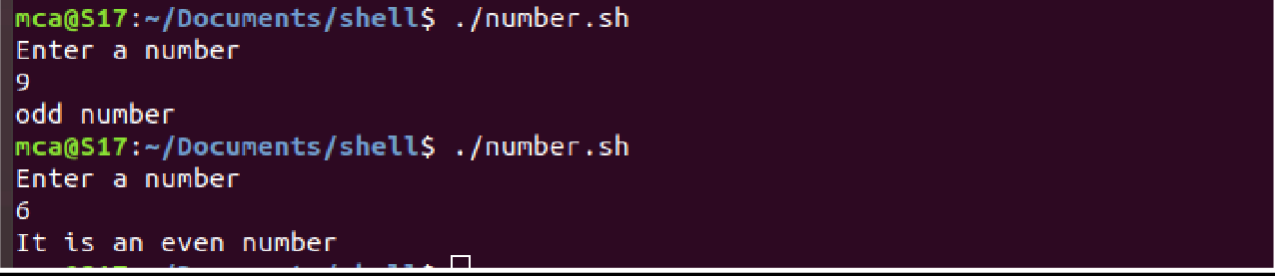

Amal Jyothi College of Engineering, Kanjirappally